**PNU EU Center**

**Pusan National University**

2015 Visiting Professors

Call for Applications

The Pusan National University EU Center and PNU GSIS (Graduate School of International Studies) welcome applications for Visiting Professors who will be actively engaged in teaching and research in the field of European Politics, Economics, Social Science and Area Studies, and etc.

PNU EU Center is the regional hub institution for European Studies in Korea to enhance awareness and knowledge of the EU supported by European Union and Pusan National University which is one of the top five research-focused universities.

* Visiting Professors Obligation
* The position is widely opened to any field of European Studies and the primary focus will be 1 or 2 courses teaching of graduate level.
* EU Economics and Political Economics would be preferred.
* The successful appointee will assist and coordinate lectures of 1 or 2 courses during semesters and provide a special lecture in the international conference and EU Study Winter School held by the EU Center.
* The successful appointee will contribute to the faculty’s teaching, engage in related professional activities and provide administrative support related to EU Studies.

**1. Condition**

* Short Term (Full Time): 1 Semester (4 months)

- September to December 2015

**2. Grant**: Flight Charge and Monthly Salary ($2,000-2,500/month)

The preferred commencement date for this position would be by the starting week of each semester. Remuneration will be negotiable within the relevant range, and salary package arrangement is available.

Conditions of employment for this position are offered under PNU EU Center and GSIS. PNU is an equal opportunity employer.

* **Application**

If you are interested in the position, please send your application with your CV by e-mail to:

* Contact Person: Mr. Sang-Hoon Nam (Researcher, PNU EU Center)
* E-mail: [pnueu@pusan.ac.kr](mailto:pnueu@pusan.ac.kr)
* Tel & FAX: +82-51-510-7398
* The closing date for application is 10th May 2015.

For more information about PNU EU Center,

please visit our website: [www.eucenter.pusan.ac.kr](http://www.eucenter.pusan.ac.kr)

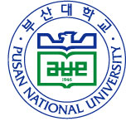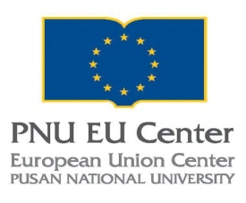

***Director of PNU EU Center***