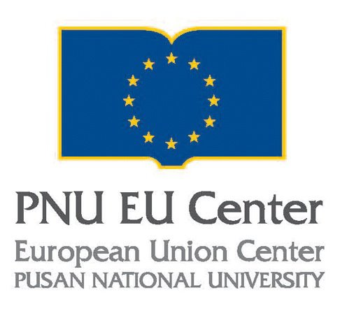 |  | Application for Visiting Professor Program
 |  | Pusan National University EU Center

Seonghakgwan 604, San 30 Jangjeon-2 dong, Geumjeong-gu, Busan 609-735, Republic of Korea

TEL: +82-51-510-7398 • Fax: +82-51-510-7398
- This application should be submitted along with your curriculum vitae.
- At the completion of this program, you must submit a report of your program.
Name  (First, Middle, Last) |  |  |  |  |  | Degree
Dept. / Institution |  |  |  |  |  | Current Position
Mailing Address
City |  |  | State |  |  | Zip  Code |  | Country
Date of Birth |  | (mm/dd/yy) | Nationality |  |  |  |  | Gender
Phone No. |  |  |  |  |  | Fax
Mobile Phone No. |  |  |  |  |  | E-Mail
Specialty
1. | Please list expected lecture courses:  (1 page of proposal or contents of lectures should be attached)
i.
ii.
iii.
2. | Briefly describe your teaching experience in academic institutions.
3. Please provide the referee’s details.

_________________________________________________________________________________________________________
Completed application should be sent to: |  |  |  |  | Ms. Jennifer S. Ryu  Researcher, PNU EU Center  Tel: +82-51-510-7398 • Fax: +82-51-510-7398  pacifist7@hotmail.com

