2012 國立臺灣大學 臺灣歐洲聯盟中心歐生系列活動
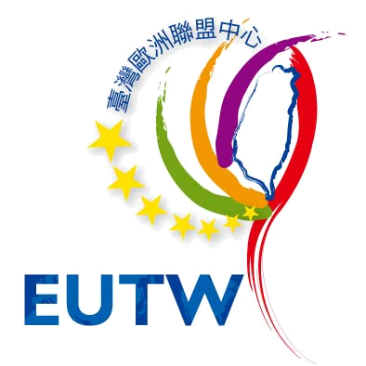

CALL FOR PROPOSAL
2012 Student Workshop on EU
To enhance the interactions between EU and Taiwan students, and further acquaint Taiwan students with EU countries in all dimensions, European Union Centre in Taiwan (EUTW) is to hold a series of workshops at National Taiwan University to introduce the EU, including her geography, history, cultures, delicacies, life-styles, or such of EU member states.
NTU students are encouraged to organise a team to propose and present in the workshop. Each team has to be at least two students respectively from Taiwan and EU countries. The selected team will be awarded $9,000 NT dollars after the completion of the presentation.

Eligibility requirements
- Application Form:
Please download and fill the form from www.eutw.org.tw, mail to EUTW (ntueutw@ntu.edu.tw) by December 14 (Fri).
- Date & Venue:
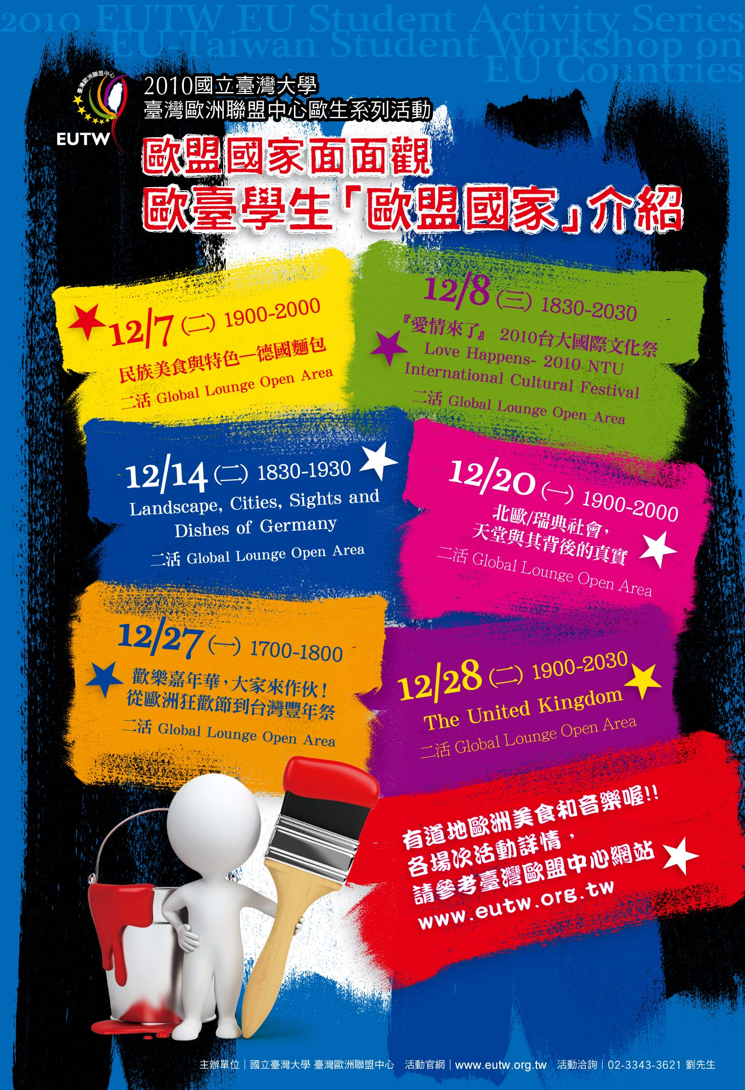
Both are up to the presenters as long as the date is within this semester. NTU Global Lounge is recommended yet other venues within NTU campus are also welcome. EUTW will cover the expense though each team is suggested to confirm the availability of the venue before submitting the proposal.

Organiser
European Union Centre in Taiwan, National Taiwan University
Contact person: Novio Liu
Tel: (02) 2351-9641 # 147
E-mail: ntueutw@ntu.edu.tw

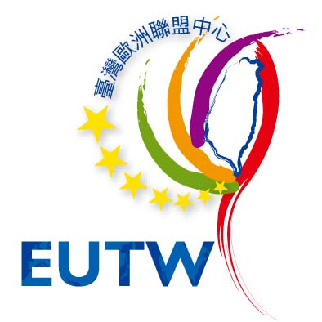
Student Workshop on EU

Application Form
Name | Phone | E-mail
Department
Theme
Date/ Time
Venue
Design of Presentation | Notes  - All forms of interactions with the audience are greatly encouraged.  - The presentation could be conducted in English or Chinese.
* Please attach the copy of your student ID cards at the back of this form.

