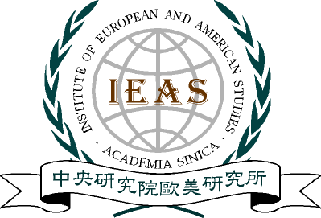
中央研究院歐美研究所

INSTITUTE OF EUROPEAN AND AMERICAN STUDIES
ACADEMIA SINICA
TAIPEI 11529 TAIWAN, R.O.C.
TEL:(02)2789-9390 • 2782-1164 • 27823108
FAX:886-2-27851787 • 886-2-27827616

Institute of European and American Studies
Academia Sinica
Symposium

Topic: Europe a la Quatre（Europe in Four Parts）
Speaker: Prof. James Caporaso（Department of Political Science, University of Washington）
Discussant: Dr. Chien-Yi Lu（Associate Research Fellow, Institute of International Relations, National Chengchi University）
Discussant: Dr. Chih-Chung Wu（Associate Professor, Department of Political Science, Soochow University）
Discussant: Dr. David W.F. Huang（Associate Research Fellow, Institute of European and American Studies, Academia Sinica）

Time/ 2: 30 p.m., Friday, 10 December 2010
Venue/ Conference Room, 1st Floor, Institute of European and American Studies, Academia Sinica, Taipei

中華民國台北市南港區11529研究院路二段130號
Allotted Time for presentation and discussion
The speaker has 45 minutes for oral presentation.
Each discussant has 12 minutes for oral presentation.
The remaining time will be for open discussion.

