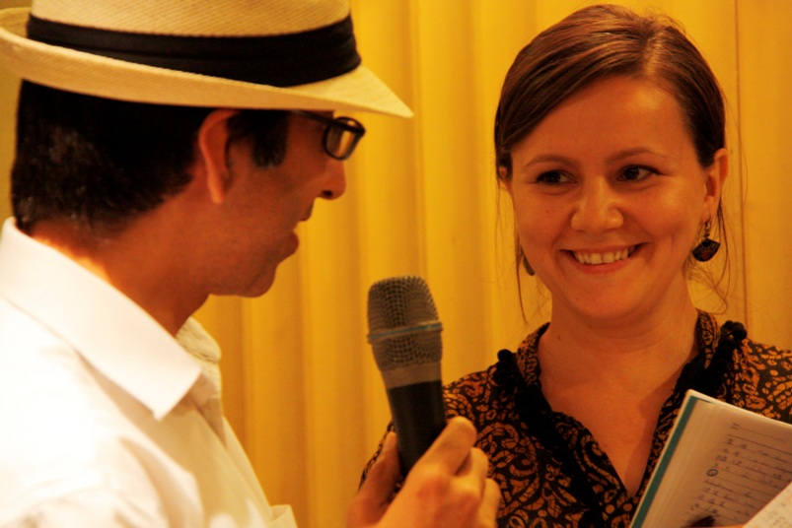
EU Officer, Asad BEG and Liliana Silvia STRUGARIU

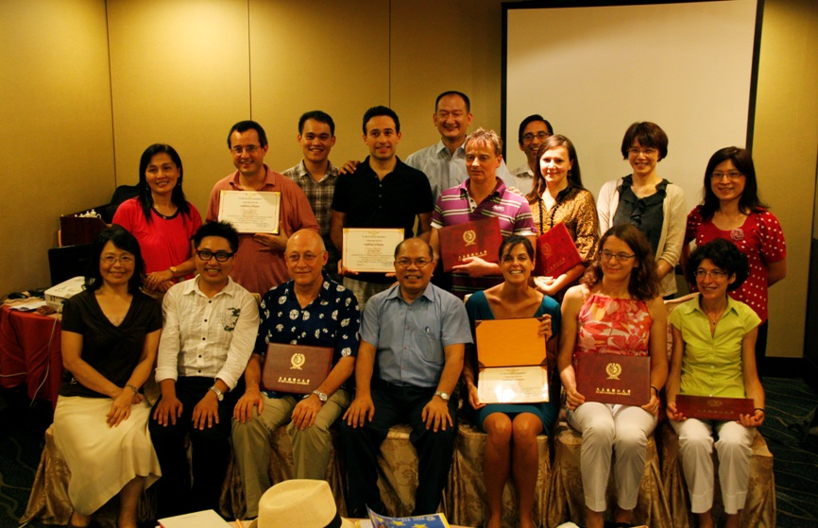Graduation

